Gear Operated Rolling
Shutter Maintenance
&
Operation Manual

CLIENT | EMBASSY INDUSTRIAL PARKS PRIVATE LIMITED-NS-MH
PRODUCT | Gear Op. Rolling Shutter
Size & Quantity | - 2500 mm X 3000 mm – 03 No  - 3000 mm X 2500 mm – 02 No  - 4000 mm X 2500 mm – 01 Nos

A DESPATCH & UNLOADING

- Loading, for dispatch, will be our responsibility. On receipt of the Rolling Shutter at site, please check and ensure that there is no physical damage to the equipment.

- While unloading the equipment from the transporting vehicle, please ensure to use slings with rated capacity higher than the gross weight of the Stationary lift in packed condition.

- ORDERING OF SPARES

- When ordering for spare, please specify the following in your Purchase Order.

  - Shutter Size

  - Part name / Description

  - Quantity required

  - Delivery period / time

  - Mode of dispatch

This would avoid ambiguity and help us serve you better.

Data sheet for gear op. rolling shutters

- CONSTRUCTION DETAILS:

- 2500 mm X 3000 mm – 03 No
- 3000 mm X 2500 mm – 02 No
- 4000 mm X 2500 mm – 01 Nos

- Shutter operation mode : Manual Operated
- Operation control : By mechanical handle through gear box
- Material : Galvanize

Motor Specification:
1.Motor Type : N.A.
2.Motor Make : N.A.
3.Motor Rating : N.A.
4.Working Temperature : N.A.
5. Continuous Single Phase operation should not exceed 7 min.
6. Continuous Three Phase operation should not exceed 15 min.

PRE – OPERATING INSTRUCTIONS: -

- Check the door is not locked in any way and that there are no obstructions that may prevent the door from opening.
- Check the door is not locked in any way and that there are no obstructions that may prevent the door from closing. Check that the area is clear of all personnel.
- In the event of a power failure, the door is supplied with a manual over ride system. This is via a hand Chain and should only be used in emergencies. PLEASE NOTE that the emergency manual over ride system is not designed for everyday use and that excessive use will cause premature failure.
- Ensure the shutter greasing properly.

ROUTINE MAINTENANCE

These recommendations are applicable to the Motorized rolling shutter considering average daily usage of 15 to 20 times. If it is used more frequently, the same time intervals for the maintenance should be adjusted accordingly.

DAILY:-
- Check shutter lock is open before operation.
- Check electrical connections for their proper working in case of motorized shutter

MONTHLY:-
- Greasing between Guide and slats.
- Check all Parts for wear or damage.
- Check all fixing are secure.
- Check correct operations of control button.

ASSEMBLIES

&

SPARE PARTS LIST

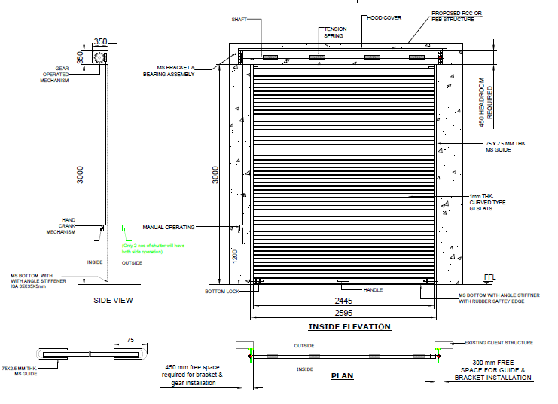

Rolling Shutter.

